Inspiring all girls to be STRONG, SMART AND BOLD

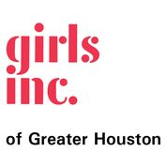
Girls Inc. inspires all girls to be strong, smart, and bold. Our comprehensive approach to whole girl development equips girls to navigate gender, economic, and social barriers and grow up healthy, educated, and independent. These positive outcomes are achieved through three core elements:
people (trained staff and volunteers who build lasting, mentoring relationships)
environment (girls-only, physically and emotionally safe, where there is a sisterhood of support, high expectations, and mutual respect)
programming (research-based, hands-on and minds on, age-appropriate, meeting the needs of today’s girls)

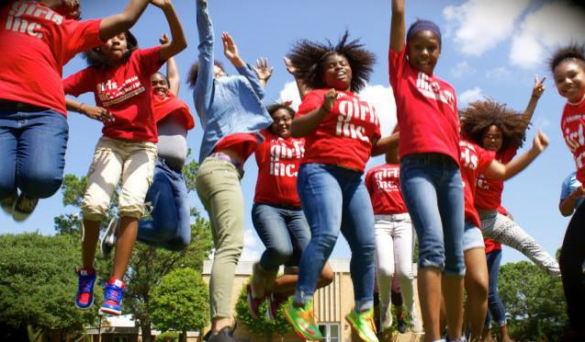
Informed by girls and their families, we also advocate for legislation and policies to increase opportunities for all girls.

Strong, Smart and Bold Programming (research based) – utilizing all three pillars of programming offered to girls 1st grade -12th grade. The programming is tailored to meet the needs of the girls while focusing on our mission to Inspire All girls to the Strong, Smart and Bold!
Imagine Science – utilizing the Girls Inc. Operation SMART approach, serving girls grades 3-8 providing programming that bridges the STEM gap among historically under-represented youth.
Project Lit – uses engaged, interactive learning to increase reading skills of girls in grades 1-3 during two 2-3 hour sessions each week after school.
Camp Smart – is a full-day camp offered in during Spring and Summer breaks for girls 6-12 that receive the interactive and comprehensive STRONG, SMART, and BOLD curriculum.
Be Bold Institute –2 two-week camps for girls ages 13-17. With a strong emphasis on STEM activities this camp works with partners such as Writers In Schools, Deloitte and Project GRAD.
Bold LeadHERS Programming – serving high school aged girls, this program provide a comprehensive opportunity for girls to develop strong leadership, advocacy, and college and career readiness skills

New 2020/2021!
#Be Bold LeadHERS Summit! – Calling all strong, smart and bold girls! We focus the day on advocacy, STEM, self-empowerment and self-confidence in a campus setting. (Date TBD)

Get Involved
Support - invest to equip girls to navigate gender, social and economic barriers & grow up healthy, educated and independent
Volunteer- the best volunteers are professionals!
Advocate- join girls, leaders, policy makers and stakeholders to drive key policy to open more doors and ensure equality for girls and women

SCOPE AND SCALE LEADING TO POSITIVE CHANGE FOR GIRLS

- 88% of our expenses (88¢ of every dollar spent) goes directly to programming for girls.
- Major watchdog agencies rank Girls Inc. at their
highest level category. Girls Inc. received a 95.52 out of 100 point rating from Charity Navigator.
- Girls Inc. is a national organization with a network of 81 affiliates across the U.S. and Canada.
1 IN 6 GIRLS will not finish high school.
OVER 1 IN 20 TEEN GIRLS becomes pregnant each year. The highest teen pregnancy rate in the developed world.
1 IN 4 GIRLS experiences sexual abuse or assault by age 17
- Girls Inc. of Greater Houston is in 16 Independent Schools throughout the greater Houston areas serving over 600 girls.
